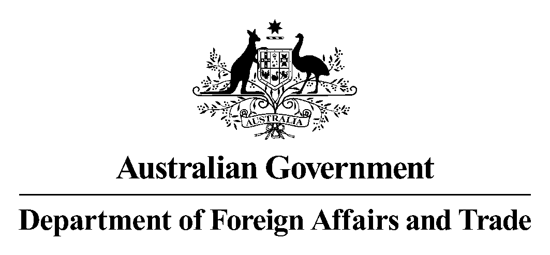

Frequently asked questions

Direct Aid Program

Australian Embassy, Thailand

What is the Direct Aid Program?
The Direct Aid Program (DAP) is a flexible small grants program funded from Australia’s aid budget and managed through the Department of Foreign Affairs and Trade’s overseas posts. DAP advances developmental outcomes in Official Development Assistance (ODA)-eligible countries with projects primarily focused on practical and tangible results.

Who can apply?
Funding is available on a not-for-profit basis to organisations, community groups and individuals engaged in development activities in Thailand. Applications cannot be accepted from commercial operations.

What kind of projects does DAP support?
DAP projects must have a tangible humanitarian or developmental outcome and/or make a practical contribution to building the capacity of recipients in a relevant and appropriate ODA-eligible sector.
We welcome applications from all over Thailand. We particularly encourage applications from communities in the Greater Mekong region and from disadvantaged rural communities throughout Thailand.
The DAP Program in Thailand focuses on:
- improving community health (e.g. through delivering a mobile health clinic to a remote area);*
- supporting schools or education (e.g. by supplying additional books to a school library);*
- improving small-scale infrastructure (e.g. by constructing check-dams to increase potable water supply in remote villages);*
- promoting gender equality and women’s empowerment (e.g. by renovating a classroom and constructing toilets in a girls’ school);*
- supporting people with disability to access the same opportunities as others (e.g. by constructing wheelchair access ramps in a rural school);*
- supporting inclusive, green growth, including strengthening institutions and promoting rural development
- protecting the environment (e.g. by supporting the use of renewable energy at a school by turning organic waste into renewable energy);*
- capacity building in the areas of governance, decentralisation and human rights (e.g. by holding workshops to advise of rights within the domestic legal system).*
Projects in other areas are still eligible but may be given a lower priority.
Projects must usually finish by May 2020. This deadline can be extended if there is a good reason and the DAP Committee gives approval.
Most projects have a budget of between AUD4,000 to AUD24,000 (THB100,000 to THB500,000).

Is my project eligible?
To be eligible, projects must:
- qualify as Official Development Assistance (ODA) and not be commercial in nature;
- have tangible humanitarian or development outcomes, and/or make a practical contribution to building the capacity of recipients in a relevant sector;
- produce results that will last beyond the end of the project, with any recurrent costs being met through other non-DAP funding;
- involve a demonstrated commitment by the local community;
- be technically feasible and able to be implemented within the agreed time-frame;
- have limited staffing and/or administration costs;
- have the capacity to meet accountability requirements, including progress reports and acquittal of funds;
- implement appropriate child protection, fraud control, anti-corruption, environmental protection and workplace health and safety measures;
- not directly or indirectly support terrorist groups or sanctioned entities;
- appropriately acknowledge Australia’s contribution.

What kind of projects doesn’t DAP support?
DAP will usually not fund:
- running costs and administrative expenses (e.g. staff salaries, office rental and utility costs, spare parts, office supplies, routine maintenance and repairs);
- salaries or fees for consultants and advisors, where they are a large part of total costs;
- any project using asbestos in its construction;
- micro-finance projects or micro-credit schemes;
- academic research;
- commercial ventures (unless it can be demonstrated that any profits flow to the community as a whole or will be reinvested in the community project).

- How do I apply?
Please apply online using Smarty Grants:
Thai: https://dap.smartygrants.com.au/BangkokDirectAidProgramTHAI2019-2020
English: https://dap.smartygrants.com.au/BangkokDirectAidProgram2019-2020
Project proposals must be received by Friday 27 September 2019.
Proposals must include details about project scope, beneficiaries, activity descriptions, cost estimates, outputs, a realistic timeframe and clear results. Please ensure you complete all questions relevant to your proposal.
Applicants must state if they have sought support from other possible funding sources for the proposed activity, or if the proposed activity is being implemented in conjunction with activities funded through other sources.

How are projects chosen?
The Embassy’s DAP Committee selects projects annually based on the online applications. When assessing applications, the DAP Committee will consider whether:
- the project is eligible to receive DAP funding (see section 4 above)
- the project is in a priority sector (see section 3 above)
- there is local participation in the initiative and a clear need for support;
- the applicant can successfully carry out the project, including meeting expenditure and reporting deadlines;
- the applicant is aware of any risks and has strategies to address them.
As part of the application process, applicants are required to submit two written references. A referee should be a credible individual from outside your organization who is familiar with the applying organization and can vouch for you and your work. Referees may be contacted to discuss the applications.
The DAP Committee will advise all applicants in writing as to whether their project has been successful or unsuccessful as soon as possible after the completion of the selection round. Unsuccessful applicants may seek feedback on their applications from the DAP Committee by emailing dap.bangkok@dfat.gov.au.

What conditions apply?
Successful applicants must sign a grant agreement outlining their responsibilities. If these terms and conditions are not met, DAP recipients will be required to repay the grant to the Australian Embassy.
All project recipients are required to provide accurate reports on their projects. This includes an acquittal report due at the completion of the project. An interim report is also required for projects that have an approved delivery period of more than one year. Acquittal reports must be completed online using the SmartyGrants system and must provide an accurate assessment of the tangible outcomes achieved, as well as evidence of expenditure.
- Who can I contact for further information?

Australian Embassy, Bangkok

Tel: (02) 344 6371 (English) or (02) 344-6362 (ภาษาไทย)
Email: dap.bangkok@dfat.gov.au

See criteria at “is it ODA?’ factsheet at https://www.oecd.org/dac/stats/34086975.pdf
As identified in http://dfat.gov.au/international-relations/security/sanctions/pages/consolidated-list.aspx#list; https://www.nationalsecurity.gov.au/Listedterroristorganisations/Pages/default.aspx

